DougieBase

A DataBase. A PWA coded in JavaScript and jQuery



Doug Dyer Victoria BC

TAble of  
Contents

Chapter 1

Dougiebase Chapter 1

Introduction 1

What can it do ? 1

Features 2

Installation 3

Connect to the web server

About the Service Worker

Add to Home Screen ………….……………………………………………. 4

**Initial steps to get started……………………….. 4**

The first window. ………….……………………………………………

Create New DB. ………………………………………………………… 5

Rename the database. …………………………………………… 7

Create first Note/Record. ………………………………………… 9

Create the second data field. …………………………………… 10

Preferences ……………………………………………… 14

SHOW and HIDE options …………………………………………………. 14

Make SEARCH Case Sensitive. ………………………………………… 14

Include time in table date edit …………………………………………… 14

Change Colours. ……………………………………………………………… 15

A word about the SCROLL buttons ………………………………… 16

Add Note ………………………………………………. 17

Create a new record or note…………………………………………………18

The second notes data field ………………………………………… 18

Add date. …………………………………………………………………………. 19

The colon delimiter ………………………………………………………. 19

Note options ………………………………………………………………. 19

Delete Record. ………………………………………………………. 20

Edit ……………………………………………………………………… 21

View Entire Record ………………………………………………. 22

**Chapter 2**

The Table …………………………………………………. 24

Overview ……………………………………………………………………. 24

Creating a Table ……………………………………………………………………. 26

The New Table window …………………………………………………………. 27

Editing a Table .. changing the layout

Adding a field. ………………………………………………………………… 31

Enter data into the newly created Dynamic fields …………. 33

Deleting a field ………………………………………………………………. 35

Editing the Date …………………………………………………………. 36

Search ……………………………………………………….. 37

Overview. ………………………………………………………………… 37

The Found Records List ………………………………………………. 39

SORT ……………………………………………………….. 40

The sort options ………………………………………………………. 41

File management ………………………………………… 42

Delete a database ………………………………………………………. 42

Backup and Restore …………………………………………………….. 43

Backup ……………………………………………………………………………. 43

Restore ……………………………………………………………………………. 44

**Using Links (urls) in DOUGIEBASE ……………. 48**

Pre-link and Post-link data entry ……………………………………. 48

Use link labels in Table. …………………………………………………. 49

About the dAtabase ………………………………… 50

Miscellaneous comments ……………………….. 50

# DOUGIEBASE Introduction

DougieBase is an interactive Progressive Web App (PWA) written in JavaScript, using jQuery libraries. It can be downloaded directly to your device and Added to your Home Screen (A2HS). It was developed using an Apple iPad Pro 9.7” mobile tablet, using familiar Apple tablet developers’ tools such as the Textastic code editor, and Inspect IDE. It is based on web browsers’ JavaScript IndexedDB interface, a javascript based storage engine that runs on most modern web browsers. Development of DougieBase used the Safari web browser.

## What can it do?

As a Progressive Web App, DougieBase is an interactive database, allowing the user to customize its appearance on the fly. This same interactivity facilitates DougieBase being able to present the user with tailored context sensitive instructions and help while using, hopefully facilitating its ease of use. As a PWA it can be run online and offline without internet connectivity.

Detailed installation instructions follow in the installation section.

Details of use and editing are found in the appropriate content chapters. Main features are listed below:

**Features**:

* Interactive DataBase. Create any database with up to 100 records and any number of fields (columns).
* Automatically creates its own record table, using the initial record entries’ four fixed fields, and allowing limitless additional dynamic fields to be added
* As a web app it runs in all modern browsers
* Runs both online and offline
* Two fixed areas of text data storage per record of limitless capacity, editable at any time.
* In the table, all fields of each record can be edited at any time..text changed in both dynamic and fixed fields. Dynamic fields can be added or deleted from the table
* Dynamic fields can be created or deleted on the fly. (Fixed fields can not be deleted, but their body text can be edited at any time)
* Records can be sorted in alphabetical or reverse order, referenced on the title field
* Records can be searched referenced on the title field
* The table can store ‘active links’
* Color themes can be changed at any time.
* Dark and light modes

## Installation Instructions:

* Download from web server
* Service worker
* Add to home screen

If you are installing from the installation email, tap on the ‘Hosting Service URL’ link supplied in the body of the email. Otherwise enter the ‘Hosting Service URL’ into the address/search bar of the web browser you wish to use to run DougieBase. Safari is recommended. (See comments below). The installation host web site will put a message on your screen showing ‘Installing DougieBase Version 1’. Tap OK to continue or Cancel to Abort. The next message confirms the registration of the Service Worker. It is the service worker that places all the necessary program files into the browser’s internal memory, allowing the app to run offline without an internet connection. DougieBase will be installed into your web browser, and you are presented with the initial DougieBase opening screen. (See photo page 5). At this point you can ‘Create a New Database’ (page 5), or ‘Restore a Database from Backup’ (page 44). I recommend that you use the provided database backup file titled ‘Database Sample’ and use the Restore Database option (see page 44) to load in the sample database to give you a quick idea of how DougieBase works. This text file is included in the installation email as a .pdf file. Open it from the email, or load it from the link provided in the About Database section of DougieBase. (Page 51). After opening the pdf file use the iOS Copy/Paste operation to copy the data to the Clipboard and then to Paste the backup data into the Text Area window of the ‘Restore Database’ section of DougieBase. After completing this process a database called Locomotive Roster will be listed in the initial opening window of DougieBase. Double tap this filename to load in the database and from here you can play with all the DougieBase options.

## Add to home screen

After DougieBase has been opened in the browser window, you need to add the DougieBase PWA app icon to your home screen. This is an easy task in Safari mobile. It also works in desktop Chrome Firefox and Edge browsers. Apple chose not to allow Chrome mobile (? or other browsers?) except Safari to add an app icon from a PWA to an iOS device’s home screen. For this reason it is recommended to use Safari to run DougieBase on an iOS device. This restriction should not apply to any desktop browser running on a pc or laptop provided the browser has the capability to ‘Add to Home Screen’. Browser documentation may refer to this capability under the heading A2HS.

On Safari in iOS the procedure is simple. After you have installed DougieBase in your browser’s screen, go to the tool bar share sheet action icon and choose ‘Add to Home Screen’. When you choose this option, Safari adds the DougieBase app icon to your home screen. You treat this icon like any other app icon on your device. Even though DougieBase is a PWA app running on Safari, it appears on your device’s screen as a ‘full screen’ display, just like any other native app.

You now have DougieBase installed on your device with its own app icon, and running like any other app. DougieBase will run offline or online. As DougieBase depends on the integrity of your browser’s memory, it is always a good idea to make frequent backups. (See page 43.)

## Initial steps to get started

#### When you first start DougieBase - Create first database

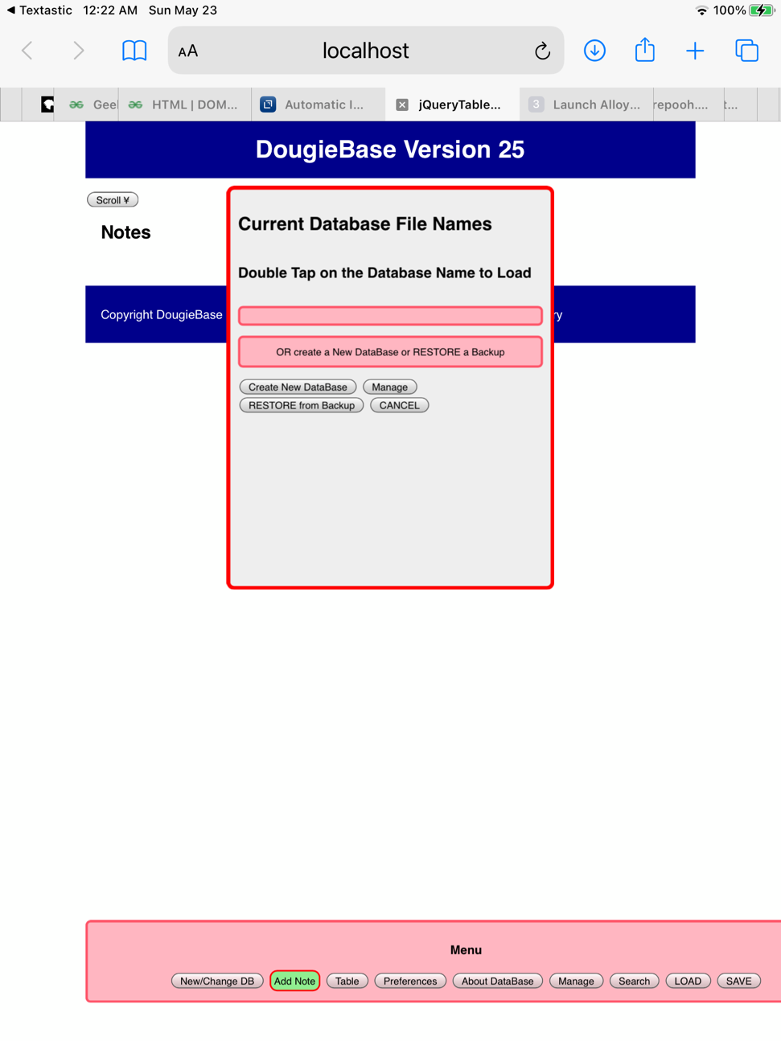The initial screen looks like this.

The main menu bar appears at the bottom of the screen. There are nine options which will be discussed individually in the manual. For the moment we will focus on “New/Change DB”, “Add Note”, and

“Preferences”. The “Current DataBase File Names” window screen appears on the first start up. This window is otherwise shown when you tap New/Change DB button in the main menu. After you have created your first and other databases, this sub window will list all the database files you have currently available.

As our first step in creating a database, tap the “Create New DB” button in the “Current DataBase File Names” window. This brings up the next screen:

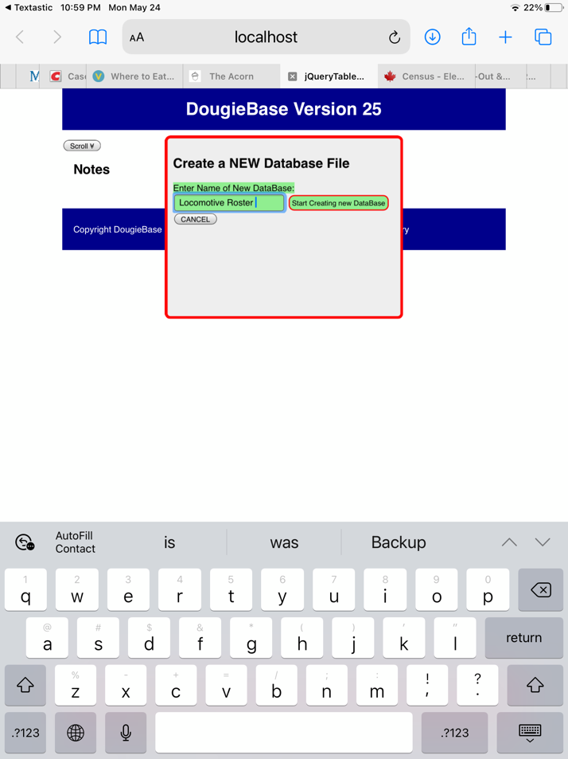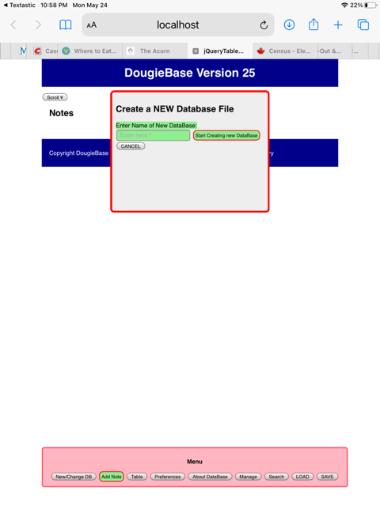

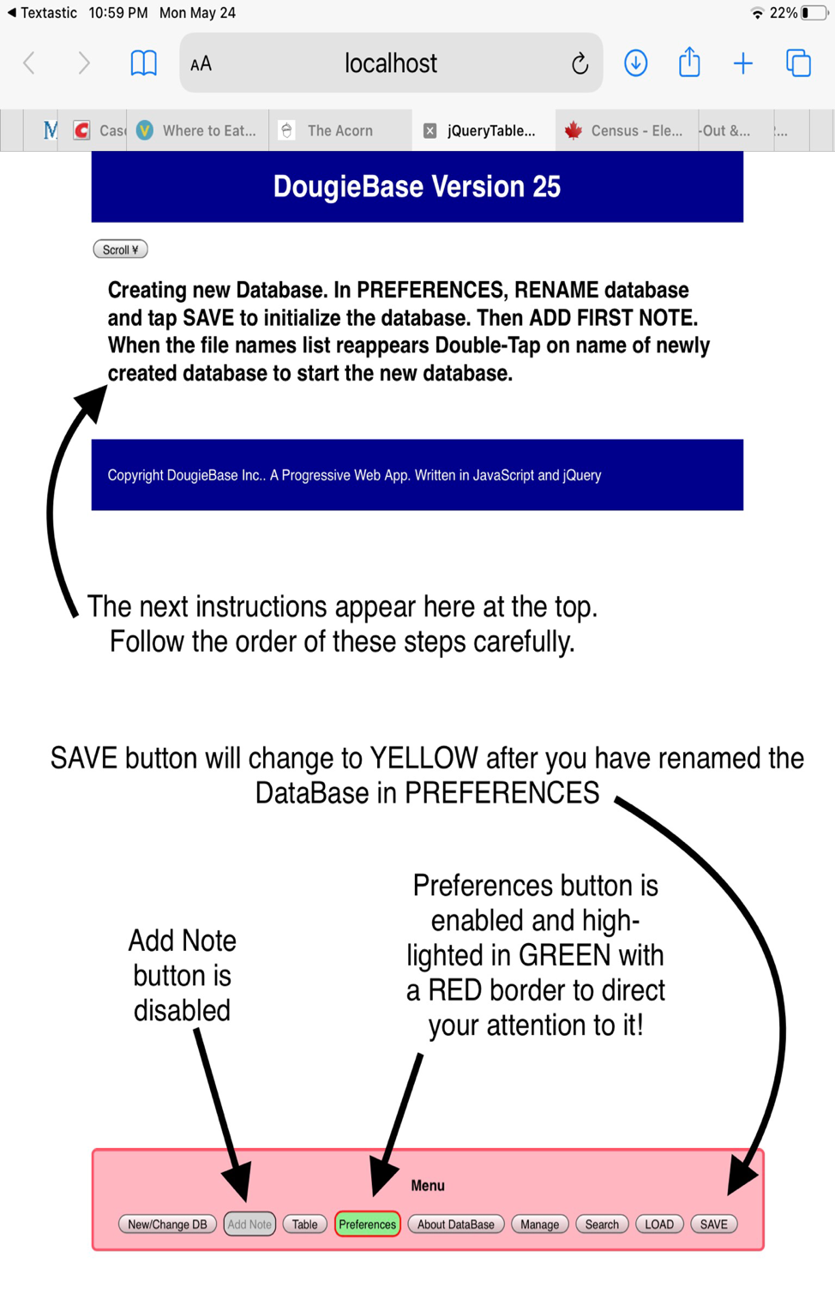In the Create a NEW Database File window, type in the name of the new database in the text input element. In this example we have named the database ‘Locomotive Roster’. Now tap the ‘Start Creating new DataBase’ button.

The next screen (above) contains important instructions. It is necessary to initialize the database at this point. You have to now go to Preferences (PREFERENCES button on main menu, and tap the RENAME DATABASE button in Preferences. You will notice that the Preferences button is highlighted in Green with a RED BORDER to draw your attention to it. The PREFERENCES window now opens. The RENAME button in PREFERENCES is now also GREEN with a RED border, indicating this is the next step. After renaming, tap SAVE (Now a YELLOW button) to Initialize the database. The next step is to ADD NOTE. The ADD NOTE button has now returned to GREEN with a RED border, indicating DougieBase is ready for you to add the first record or note.

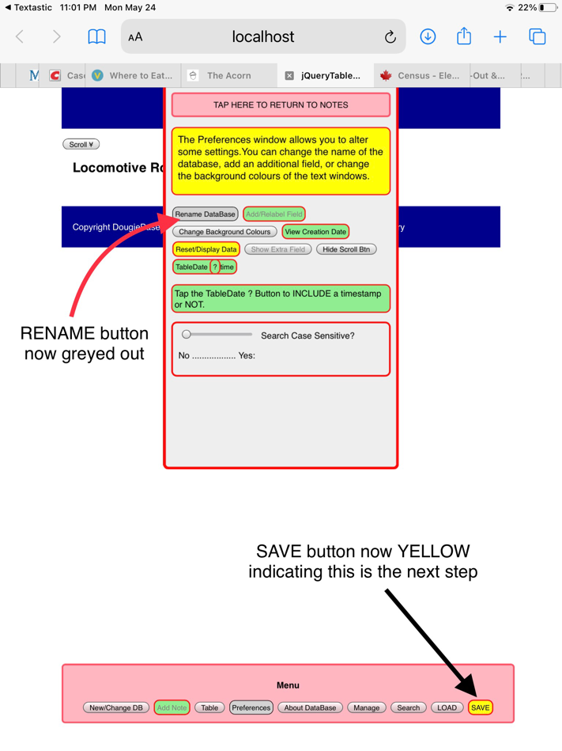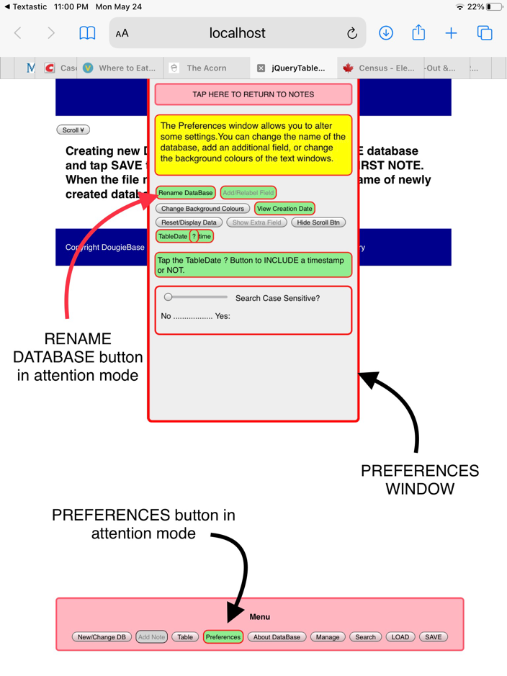The PREFERENCES WINDOW LOOKS LIKE THIS:

THE NEXT WINDOW AFTER RENAMING APPEARS WITH SAVE HIGHLIGHTED IN YELLOW

After tapping the RENAME button a miniwindow appears allowing you to rename the DataBase…(use the same name as you used to initiate or you can change the name now or later). The next screen appearing indicates that you now SAVE the new name. The SAVE button is highlighted in YELLOW and the ADD NOTE button is currently disabled. (Pg 7 right). This initializes the database. An Alert appears, indicating SAVE in progress. You are now ready to ADD your first note!

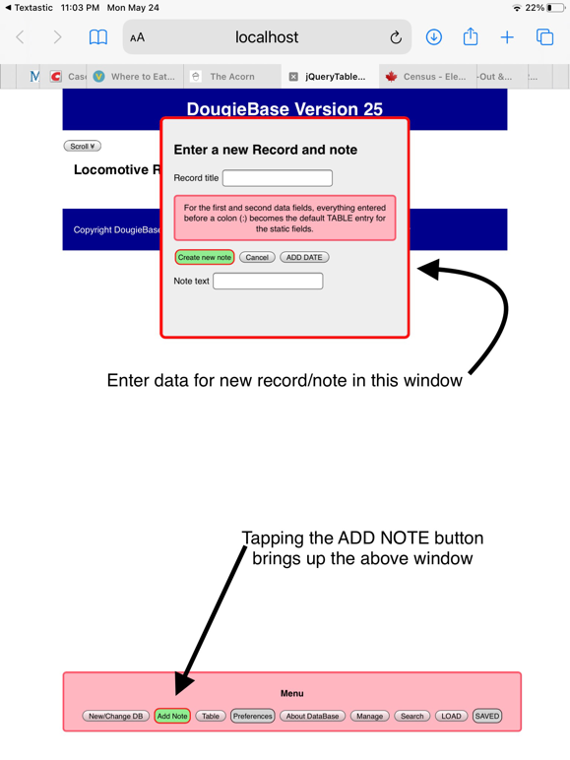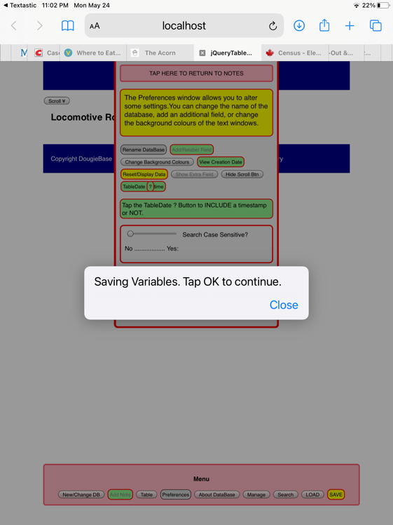

**After SAVING you are ready to ADD the first NOTE**

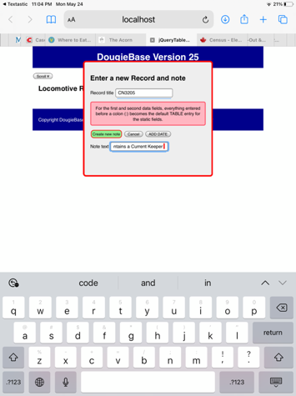**NOTES: CREATING THE FIRST NOTE**

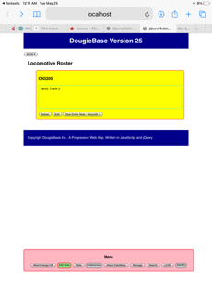

After filling in the data in the title field (which will represent the title of the first record) enter the data text in the next field. There are two text areas available in this section of the database. The second text data area is optional but recommended. You are given the option to create it and label its section title in preferences. At this point, tap on the ‘Create New Note’ button. The first record now appears in its default colour yellow.

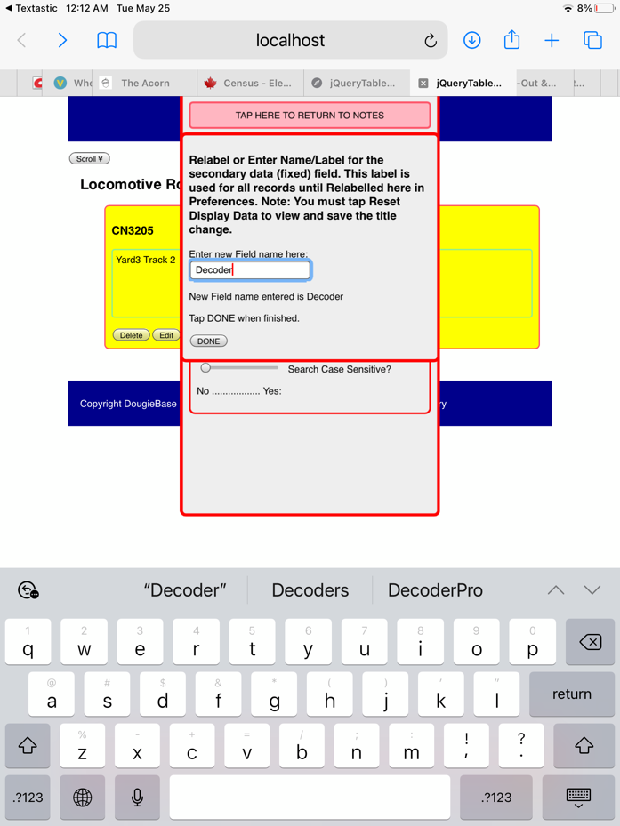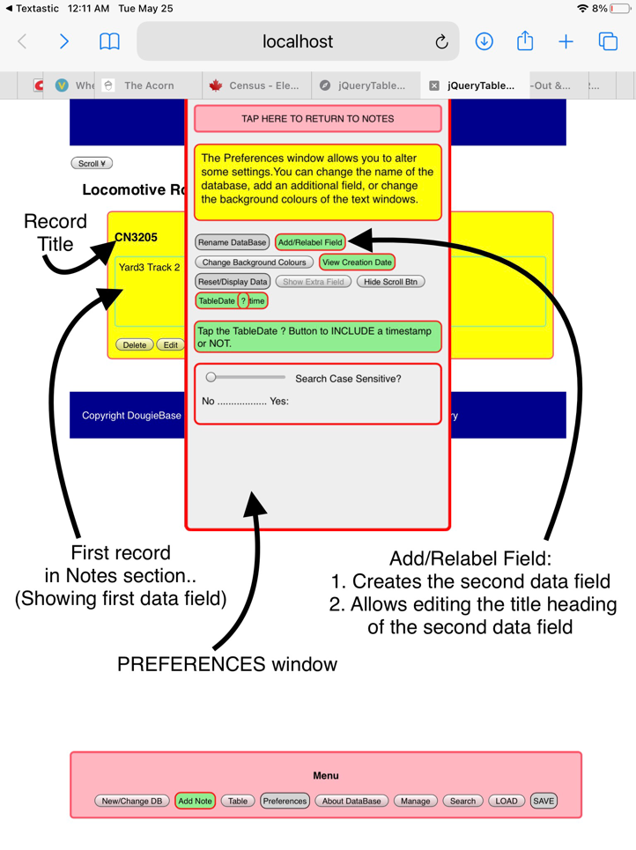Now open PREFERENCES again to create the second data field. Tap the ADD FIELD/LABEL button which brings up a new miniwindow with a text input element in which you enter the title for the second data field. In this case we entered DECODER as the title.

After entering the title for the second data field, tapping DONE returns you to the DOUGIEBASE home screen (NOTES). To enter data into the second data field, in this instance labelled DECODER, tap the EDIT button in the options menu at the bottom of the note entry. This brings up the EDIT NOTES window in which you enter or edit the text data in the first and second data fields. See the EDIT NOTES chapter for more details. Tap the EDIT FIELD DECODER button to get to the edit window of the second data field. After entering the text data into the second data field tap COMMIT CHANGES, to return to the first data field window. Now tap SAVE CHANGES to finalize the data entry for both data fields. To visualize the second data field, go to PREFERENCES and tap SHOW EXTRA FIELD. This button then reverts 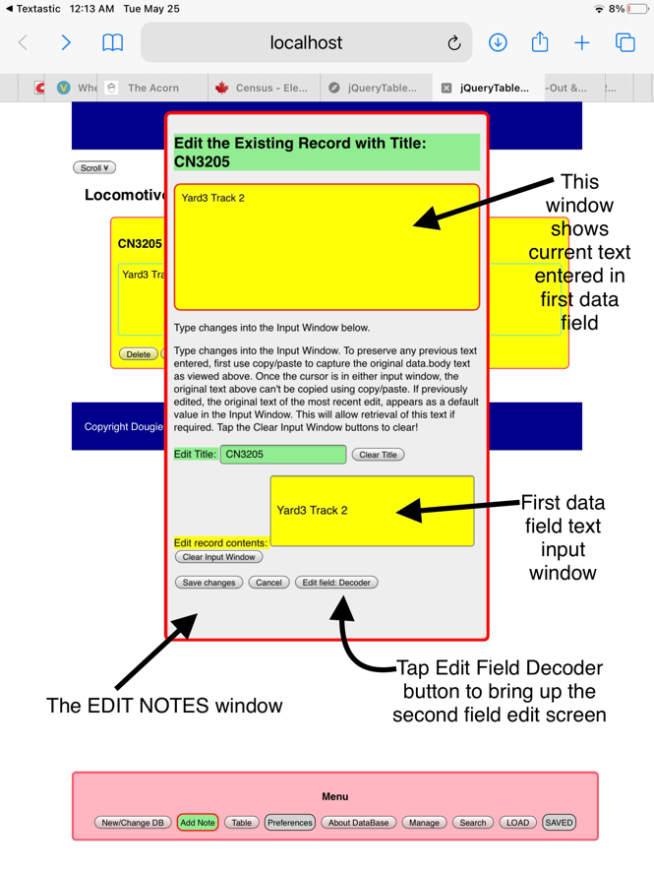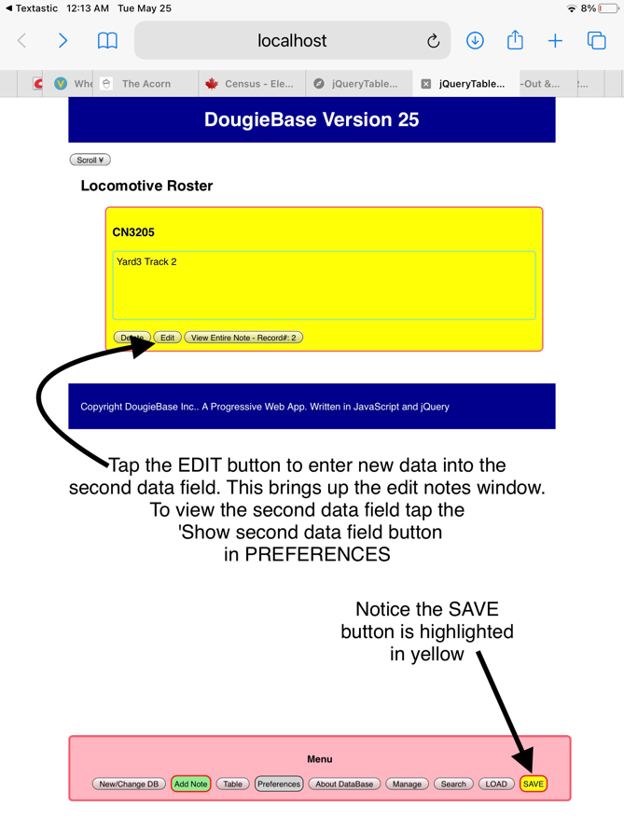to HIDE EXTRA FIELD.

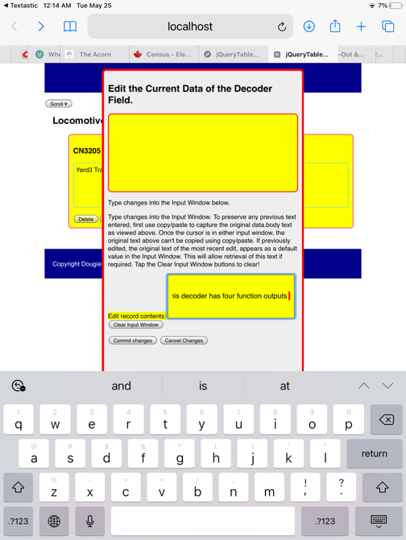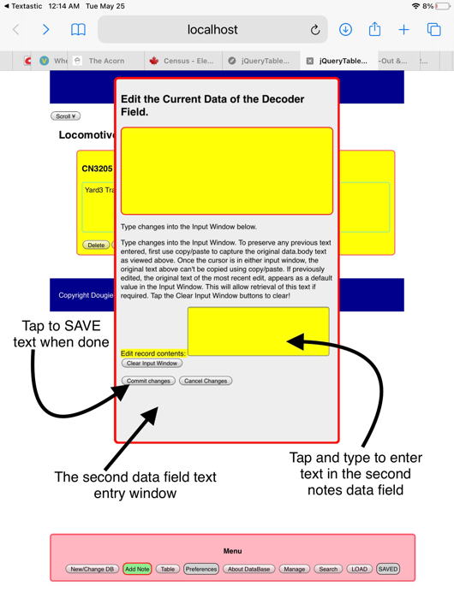Whenever you see a SAVE button highlighted in YELLOW in DOUGIEBASE it means you have to SAVE before going on to next steps. Similarly a GREEN button with a RED border means ATTENTION…this is the next step. After entering data into the second field data input window tap COMMIT CHANGES, returning to the first 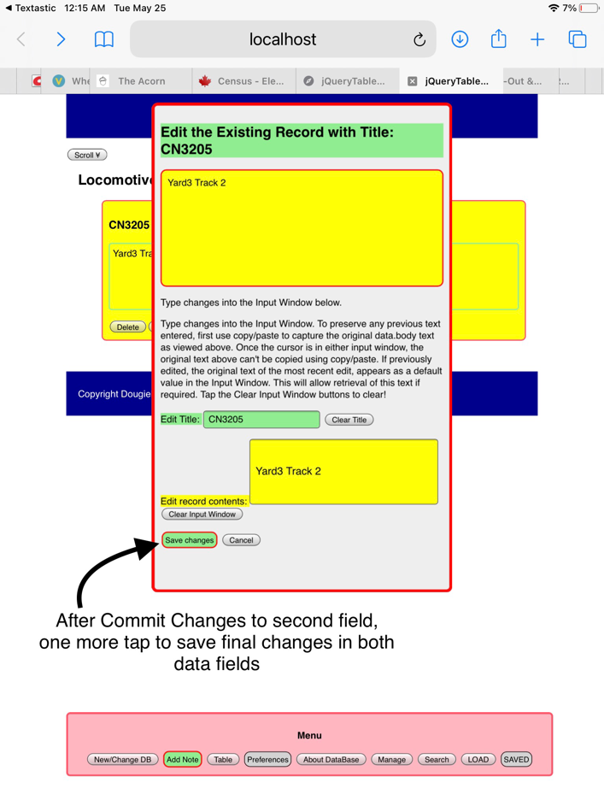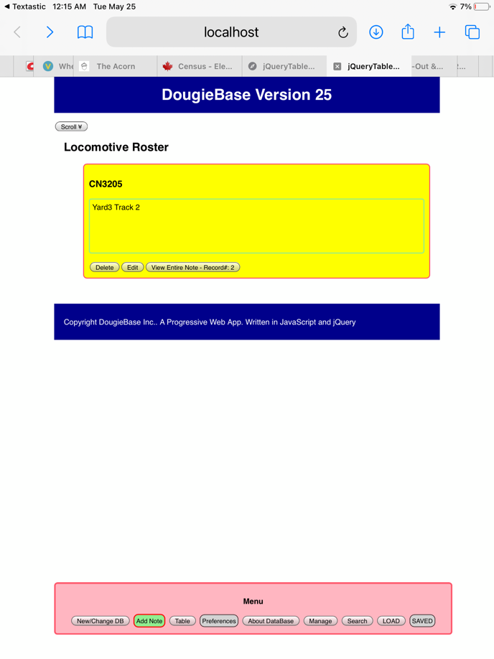data field EDIT window. Tap SAVE CHANGES (highlighted in GREEN with RED border) to finalize the data entry for the first record of the NOTES section.

After saving you are returned to the HOME SCREEN. To visualize the second data field return to PREFERENCES and tap SHOW EXTRA FIELD. Then you see the first Note of the first record entered in the NOTES section. Don’t like the colour scheme? No problem. Return to PREFERENCES and tap the CHANGE COLOURS button. See the chapter on PREFERENCES for more details

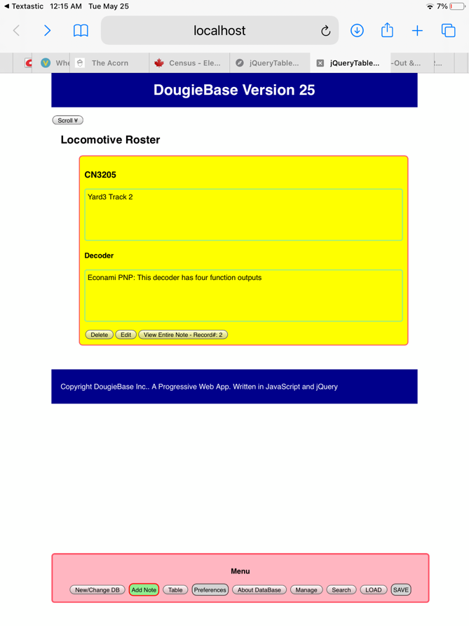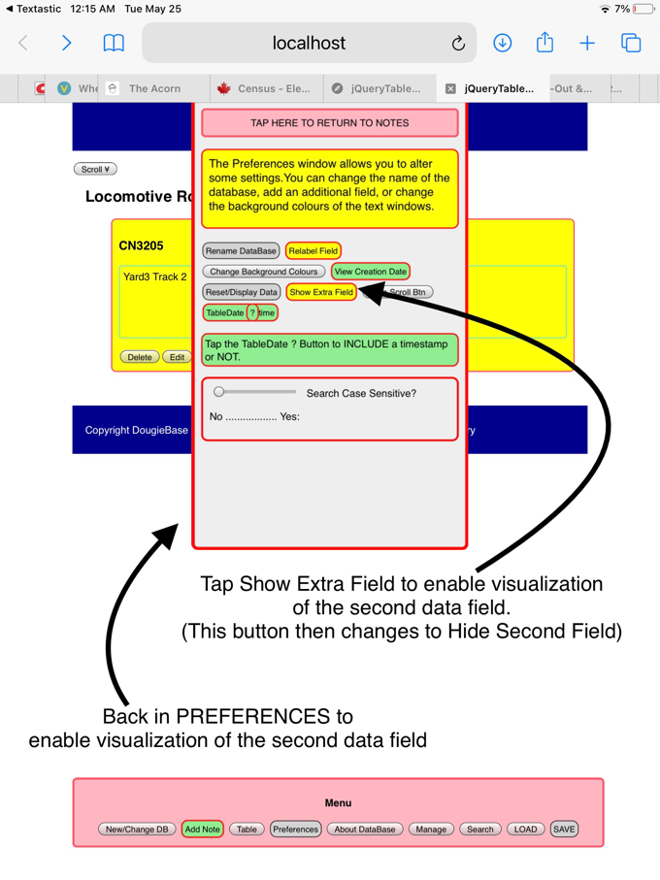.

At this stage you have created your first database and entered its first note or record. Use the PREFERENCES SCREEN to alter the colour scheme, edit the database title, show the date and change some other settings. See the chapter called PREFERENCES.

We will next discuss editing changes in notes, and creating a table for your database.

## Preferences

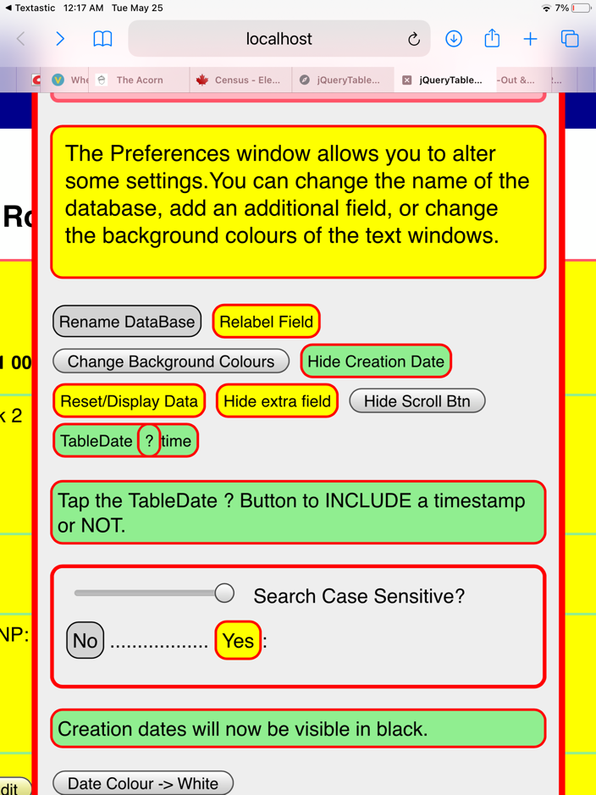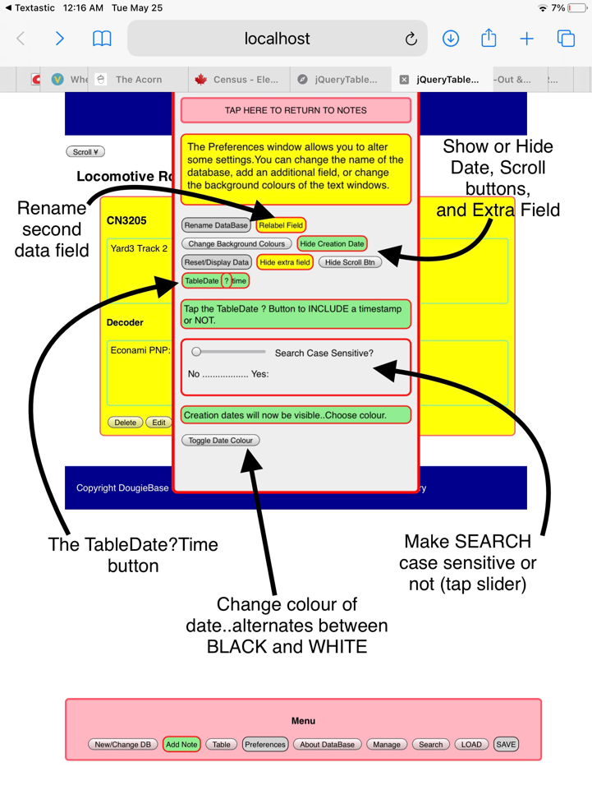

Many settings can be changed in PREFERENCES. The database can be renamed. The title of the second data field (in this example ‘DECODER’) can be renamed. You can SHOW or HIDE the date, the second data field, and the SCROLL buttons. When the record list gets long it might be convenient to ‘shorten the list by hiding the extra field. Tap SHOW EXTRA FIELD when you want to visualize it again. The top and bottom SCROLL buttons are convenient for navigating, but can be hidden here if they temporarily obscure view. There is an option to change whether the time is shown with the date when editing the date in the table. See chapter on TABLE EDIT. In PREFERENCES you can alter whether SEARCH is case sensitive or not. (Move the slider bar to the right to make SEARCH case sensitive). The text and the background colour of the display can be changed by tapping Change Background Colour and Date Color buttons.

## Changing colours

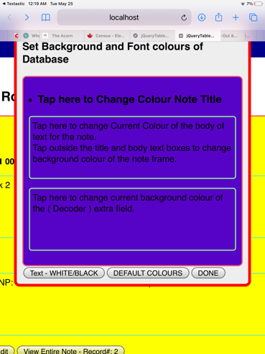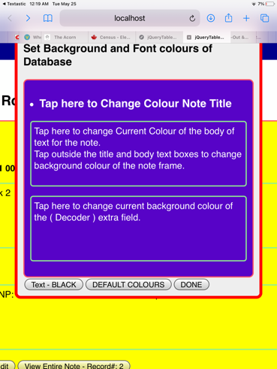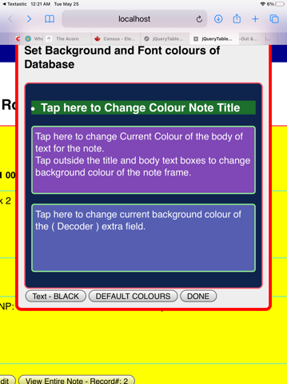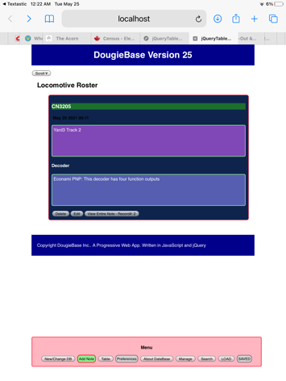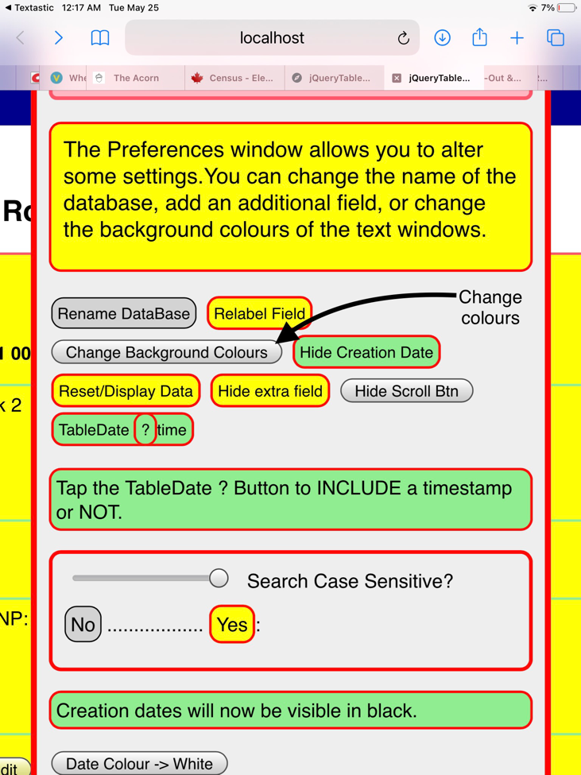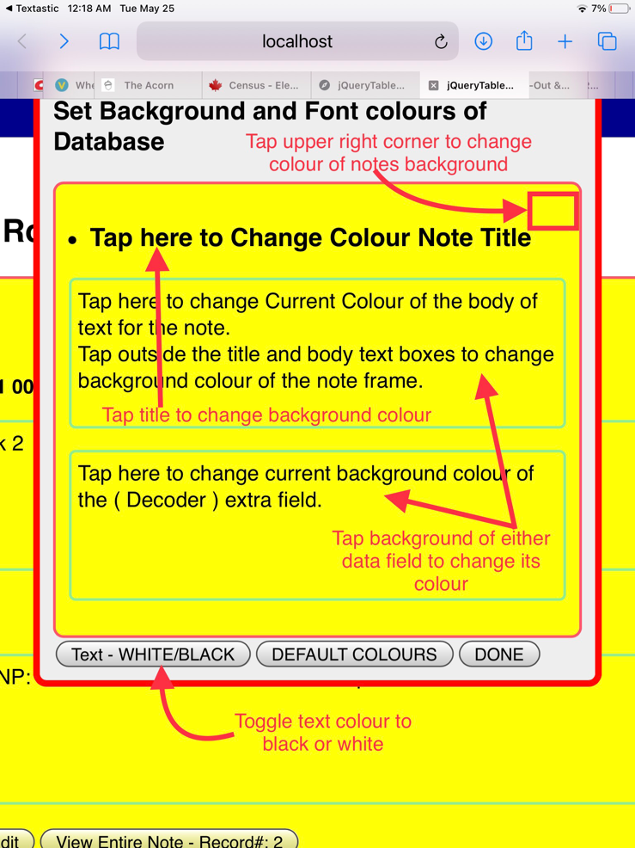You can choose the background colours of the notes screen, background of the record titled, and have different background colours of both data fields. Tapping on the upper right corner of the notes widow randomly sets colour with each tap. Random colour choices also appear with each tap of the data background and title fields. The text colour can be altered separately. See examples below.

## A word about the scroll buttons

TOP and BOTTOM scroll buttons do the obvious. They will appear when scrolling is initiated and immediately take you to the top or bottom of the record list. If they get in the way the user can disable them in PREFERENCES using the HIDE/SHOW scroll button. The smaller grey SCROLL button at top left scrolls the screen down record by record. Tapping the New/Change DataBase button, brings up the list of databases currently in the browser’s memory cache. Double-tapping on the filename will upload that database. See chapter on managing database files.

## Add note (Record)

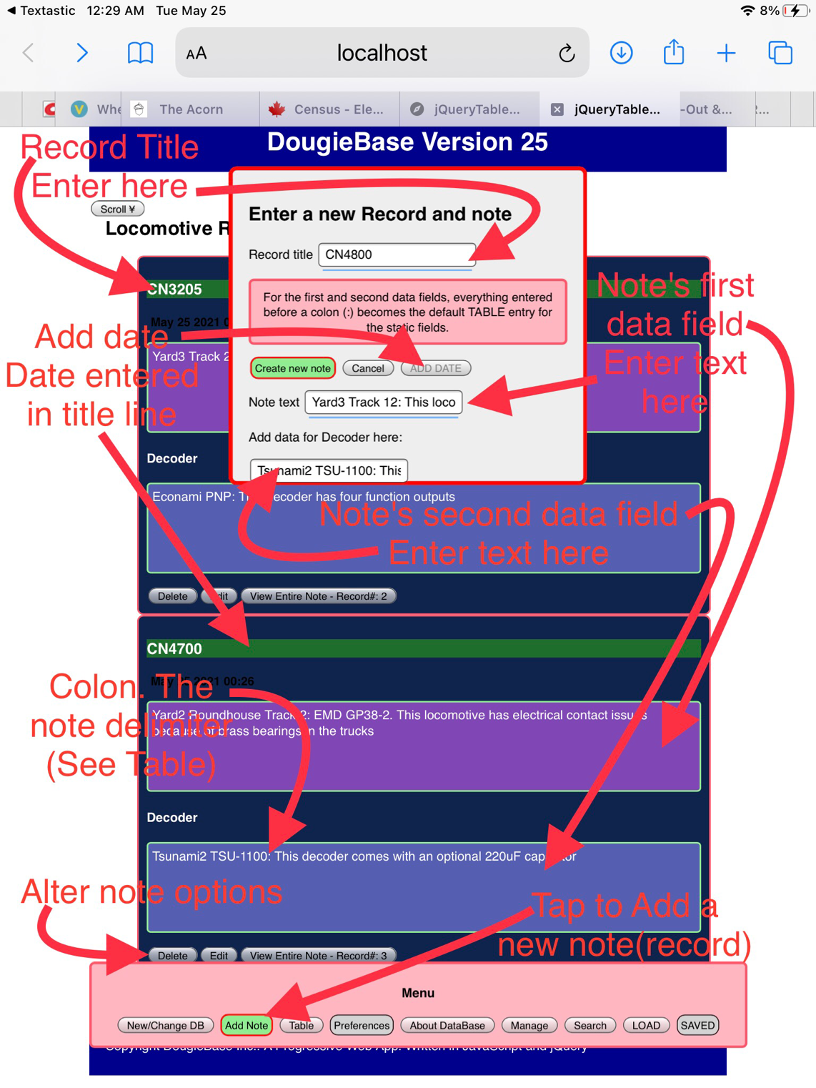DougieBase has two main sections. A Notes section and a Table section. The opening screen shows the Add Note button in ‘Attention’ mode, as this is the first step in using DougieBase. Tapping on the Add Note button brings up the ’Enter a new Record and note’ window.

### Create a new record or note

The first line of the record is the Record Title. Its text is entered in the Record Title input element. This can be edited at any time (see Edit) and its background colour can be changed at anytime using Preferences. The second segment of a record is the first data field of the record. It’s text is entered in the ‘Notes text’ input window. As with the title field, the background colour of the first data field can be changed in Preferences, and its text content edited by tapping the Edit button that shows in the Notes Options buttons at the bottom of each record. (See Alter notes options).

### The second notes data field

The third segment of a record is the second data field of the record. This field can be made to appear or not show by tapping the ‘Hide-Show Extra Field’ button in Preferences. You are given the opportunity to create this second field at the time you create the first record when initiating the database. It is recommended to do this. At the time of creating your first record you open PREFERENCES again to create the second data field. (Tap the ADD FIELD/LABEL button which brings up a new miniwindow with a text input element in which you enter the title for the second data field….see chapter re Creating a New Database). It is always a good idea when creating a database to give thought to whether you need the extra field or not. It is recommended to create the second field when first initiating your database so it is there when you need it. It can always be ‘shown’ or ‘hidden’ via Preferences. Should you create your initial database with only a single data field in Notes, you will need to re-create a new database should you later decide you need the second data field in Notes. You will notice that the first time you create a database, Preferences will have a button titled ‘Add/Relabel Field’. It is in ‘attention’ mode….green with red border. (The ‘Show Extra Field’ button is disabled). This is the button you tap to create the second data field in notes when you are first creating the database. After creation of the database, the label on this button in Preferences changes to ‘Relabel Field’ and turns to Ready mode..yellow with red border. This allows you to edit the title or label of the second data field. You will also notice that when entering a new record, the label you enter here is used by DougieBase to reference the input element for entering or editing the text for this field.

### Add Date

When creating a new record there is an option to add the date of the record creation. Tap the ADD DATE button in the Enter a New Record window. This places the creation date in the same line as the Record Title. Note that when DougieBase generates the table the date is automatically entered into the second ‘Fixed’ field of the table, regardless of whether you have entered the date in the Notes section. (See documentation on DougieBase Table for more information).

### The Colon ‘:’ delimiter

As DougieBase automatically generates a table for the data entered in notes, there is close interaction between the Notes section and the Table section of the database. In order to have the capability of limiting the amount of text entered automatically into a table cell, DougieBase uses a colon character to ‘trim off’ text entered in notes so that it does not appear in the corresponding table data cell. Any text that follows a colon in the notes data entry is excluded from the text DougieBase enters into the table cell. DougieBase will only include the text preceding the colon character entered in notes to put in the tables’s data cell. If no colon is entered in the notes data entry, all text entered in notes will be entered in the table data cell. With the colon inserted in the note, all text entered in notes following the colon is not shown in the table cell. DougieBase uses only the text preceding the colon to put into the table.

### Note options

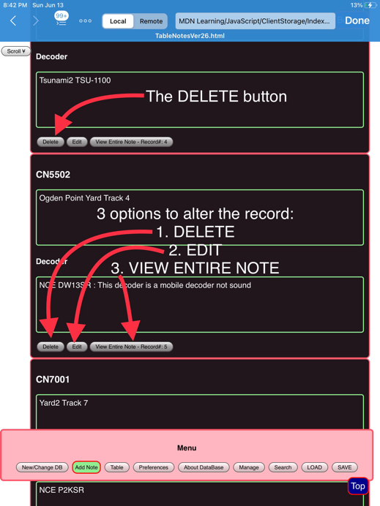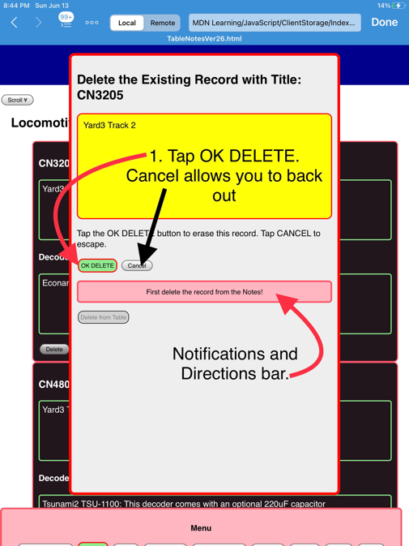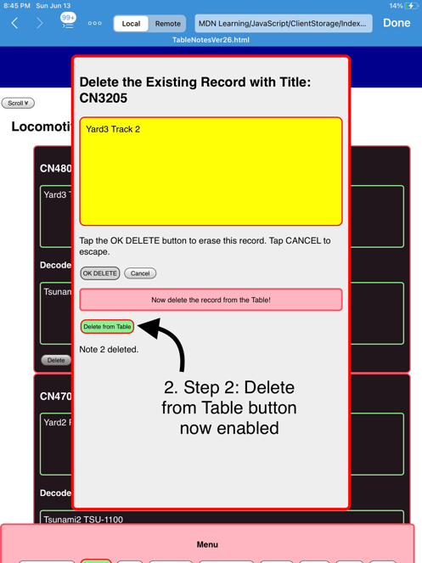At the bottom of each record are three buttons allowing the record to be altered. These are DELETE, EDIT, and VIEW Entire Note.

#### Delete Record

Tapping the DELETE button brings up the ‘Delete Existing Record with Title: A CANCEL Button allows you to change your mind but be sure after this point as a record deletion is irreversible unless you have previously backed up the database. (See database backup).

The record deletion is done in two steps. First delete the record from Notes. Tap OK DELETE. The Delete from Table button is disabled at this point because DougieBase requires this process to be done in strict order. After deleting the record from Notes tap Delete from Table which has now been enabled. DougieBase then automatically saves the new Table array and the notes records, and returns to the Notes window, showing that the record has been deleted. If you are deleting a record but have not as yet initialized or viewed the Table do so prior to deleting a record. This instance would only occur should you try to delete a record on the first time creating the database, without ever having viewed the table.

#### EDIT

Tapping EDIT allows you to make changes to the text entries in the two data fields of the Notes section. The edit window for the first data field appears. To edit the second data field tap the button ‘Edit field:*field name’.*

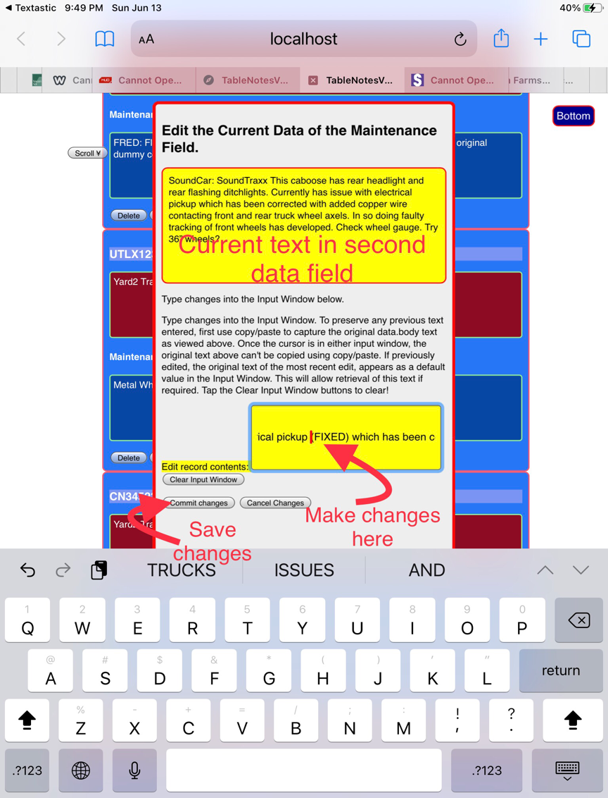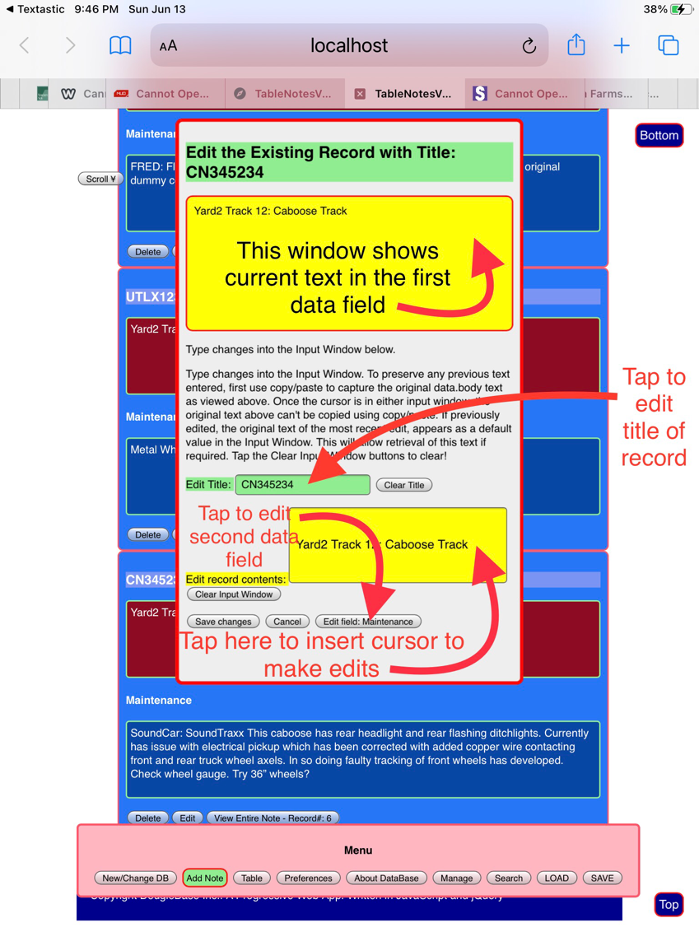**FIRST DATA FIELD SECOND DATA FIELD**

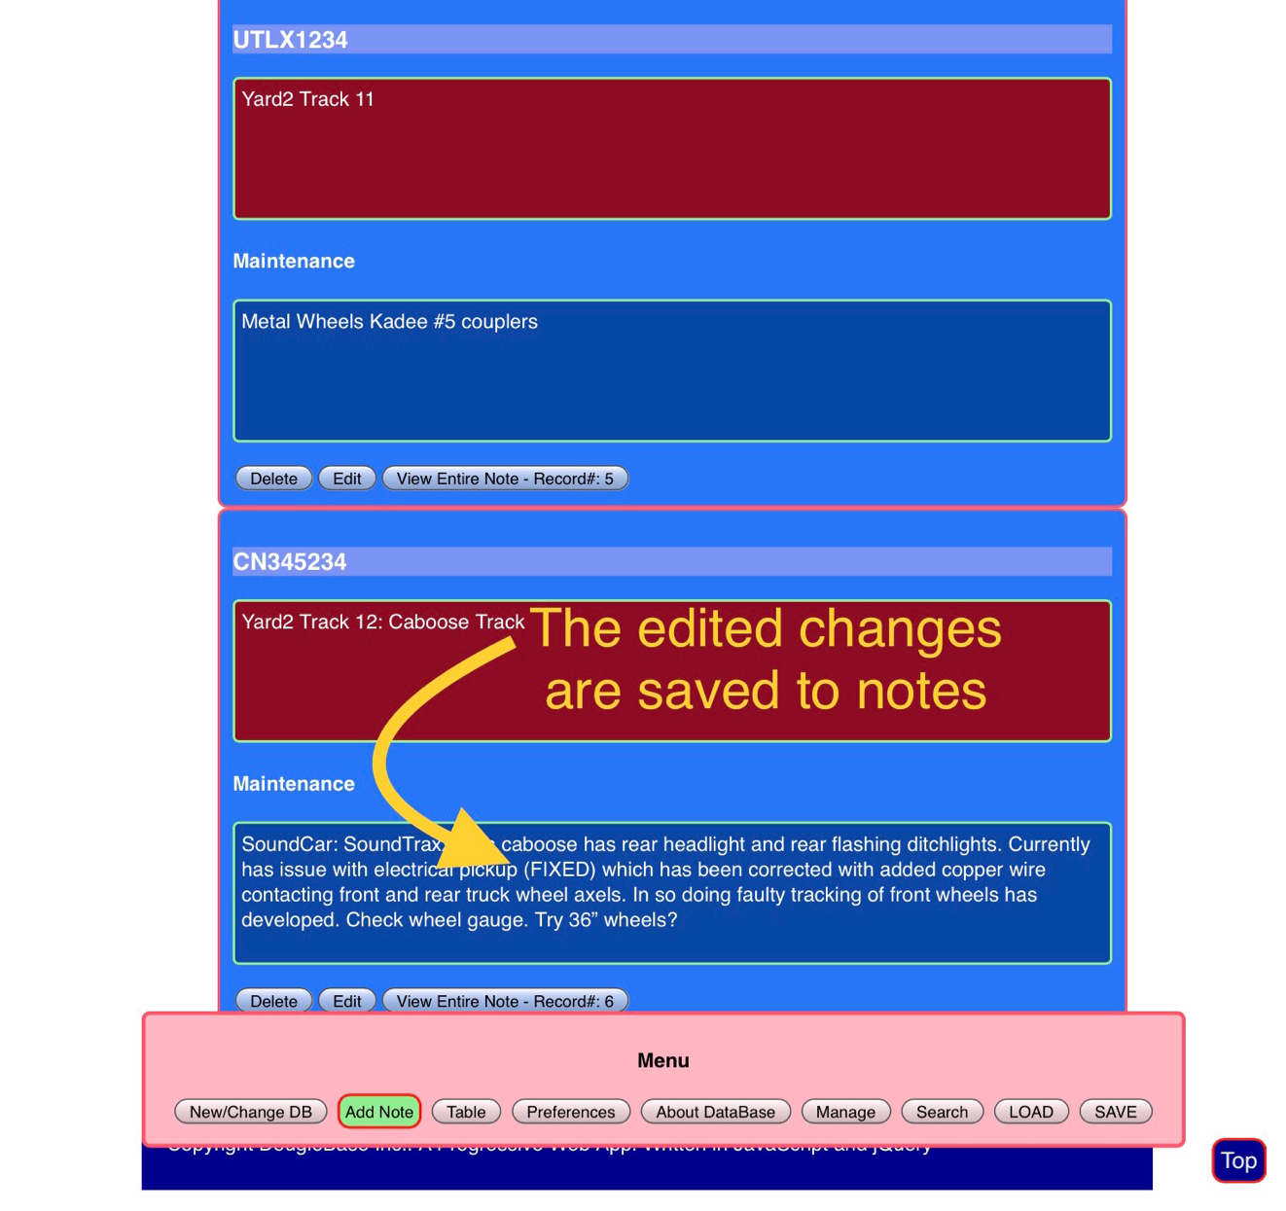After making the edits to the second data field tap ‘Commit Changes’ then tap ‘Save Changes’ to finalize. You are returned to the Notes window where you will see your edits saved.

#### View Entire Note

The View Entire Note button is provided to facilitate easy viewing of a long data entry in the Notes section. The data fields will hold an unlimited amount of text, and if larger than the viewing field, scroll bars appear to allow scrolling of the entire data entry. When you tap on View Entire Note, a separate ‘reading’ window appears with slightly larger text, and an overall larger field of view. Tapping on the viewing window toggles between the data in the first field and the data n the second notes data field. From here you can ext back to the Notes screen, or you can go to the Search Table function. From the Search Table screen, you can return to this View screen by double tapping on the record name that will appear in the search records list of the Search Table function. This will be more clear after reading the 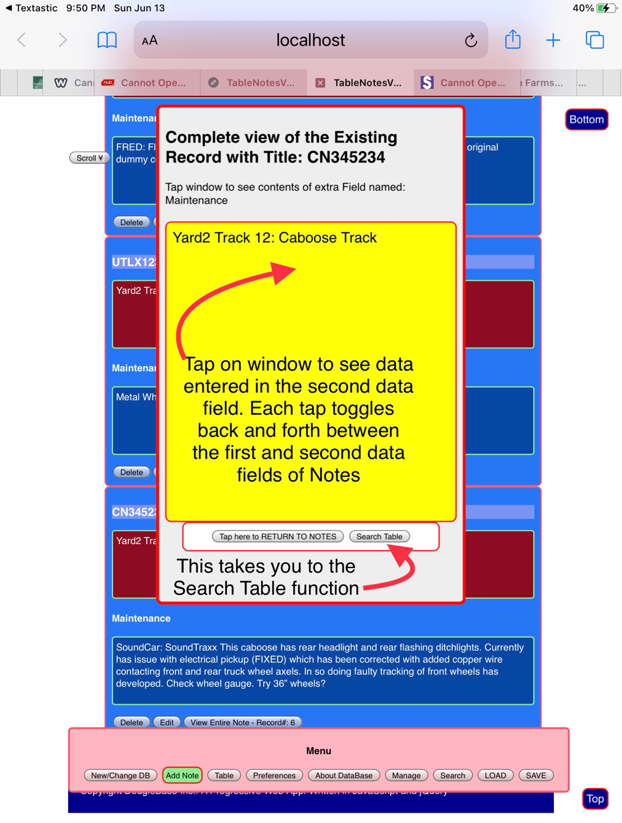documentation in the Search Table (See chapter2)

**Continue to DougieBase Chapter 2 for documentation of DougieBase Tables.**